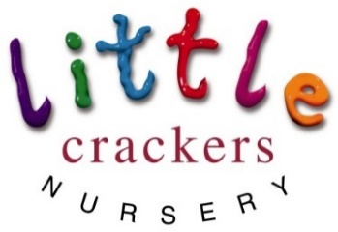
Weekly News

28th June 2019

Term time children break up on Wednesday 3rd July…  That’s NEXT WEDNESDAY!!!!!  So…  Our all year round children are celebrating!!  Soon the room will be quieter, calmer and tidier! | Nursery news:  We are having new furniture and changing the whole look and feel in the big room:  Here is a picture to give you an idea…  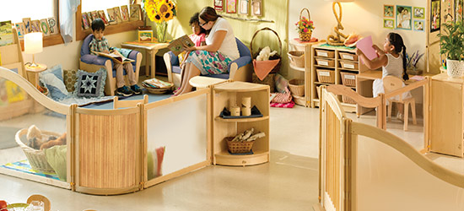
10 Fun things to do this summer!  - Paddle in the sea  - Share some books  - Have a picnic  - Grow some flowers  - Go pond dipping  - Make a cake  - Look for fairies and goblins  - Make ice lollies  - Explore somewhere new  - Ride a bike | We would all like to say a big thank you to the parents of the pre-school children who gave us the wonderful fingerprint tree to celebrate their children moving on –it is really beautiful and makes us smile. xxx
 | Don’t forget…  Term starts again on Monday 2nd September | 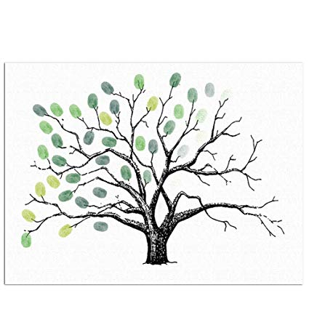

Little Crackers Nursery · Crackley Hall · St Joseph’s Park · Kenilworth · CV8 2FT
Telephone: 01926 514444 · Fax: 01926 514455 · e-mail: littlecrackers@crackleyhall.co.uk
www.crackleyhall.co.uk

Registered Charity Number 1087124 Company limited by guarantee Number 4177718

You can email Mrs Bird clarebird@crackleyhall.co.uk
or ring the nursery direct 01926 514456

